# Exercises

Your Name: STEPHEN OMONDI  
Your SUID: 946934043  
Your Email: SOOMONDI@SYR.EDU  
Date Due: 10/13/2019  
Homework #: LABWORK 1

Complete each of the following exercises. If you are unsure how to accomplish the task, please consult the coursework videos where there are explanations and demos.

1. Use built in SQL functions to write an SQL Select statement on **fudgemart_products** which derives a **product_category** column by extracting the last word in the product name. For example
   1. for a product named ‘Leather Jacket’ the product category would be ‘Jacket’
   2. for a product named ‘Straight Claw Hammer’ the category would be ‘Hammer’

Your select statement should include product id, product name, product category and product department.

**SQL QUERY:**

USE fudgemart_v3

GO

SELECT product_id,

   product_name,

   SUBSTRING(product_name, LEN(product_name) - CHARINDEX(' ', REVERSE(product_name))+1, LEN(product_name)) AS product_category,

   product_department

FROM dbo.fudgemart_products

GO

**SQL QUERY OUTPUT:**

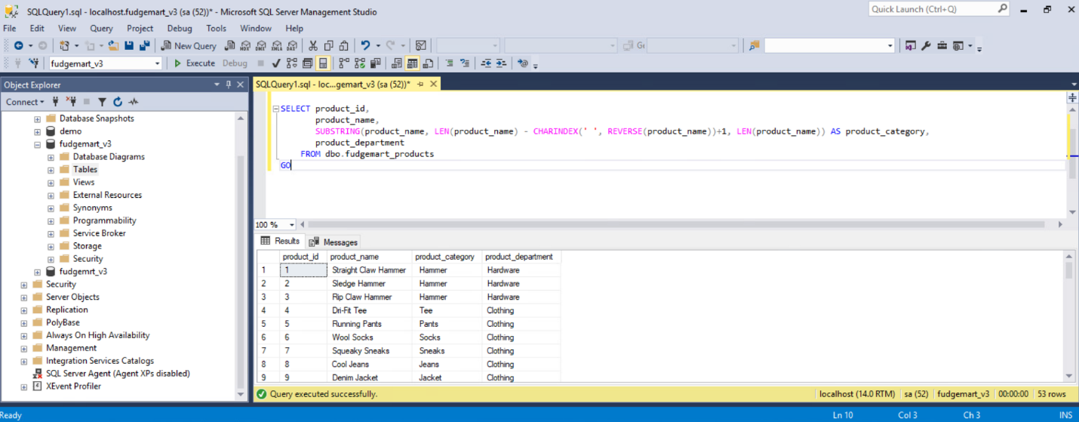

1. Write a user defined function called **f_total_vendor_sales** which calculates the sum of the wholesale price * quantity of all products sold for that vendor. There should be one number associated with each vendor id, which is the input into the function. Demonstrate the function works by executing an SQL select statement over all vendors calling the function.

SQL

----drop the function if it already exists

DROP FUNCTION IF EXISTS f_total_vendor_sales

GO

DROP function IF EXISTS dbo.f_total_vendor_sales

GO

CREATE FUNCTION dbo.f_total_vendor_sales(

@vendor_id int

) RETURNS int AS

BEGIN

declare @total int

set @total = (

 SELECT SUM(order_qty * dbo.fudgemart_products.product_wholesale_price) AS total_vendor_sales FROM dbo.fudgemart_order_details

 JOIN dbo.fudgemart_products ON dbo.fudgemart_products.product_id = dbo.fudgemart_order_details.order_id

 WHERE dbo.fudgemart_products.product_vendor_id = @vendor_id)

RETURN @total

END

GO

--call the function

SELECT dbo.f_total_vendor_sales(5)

OUTPUT

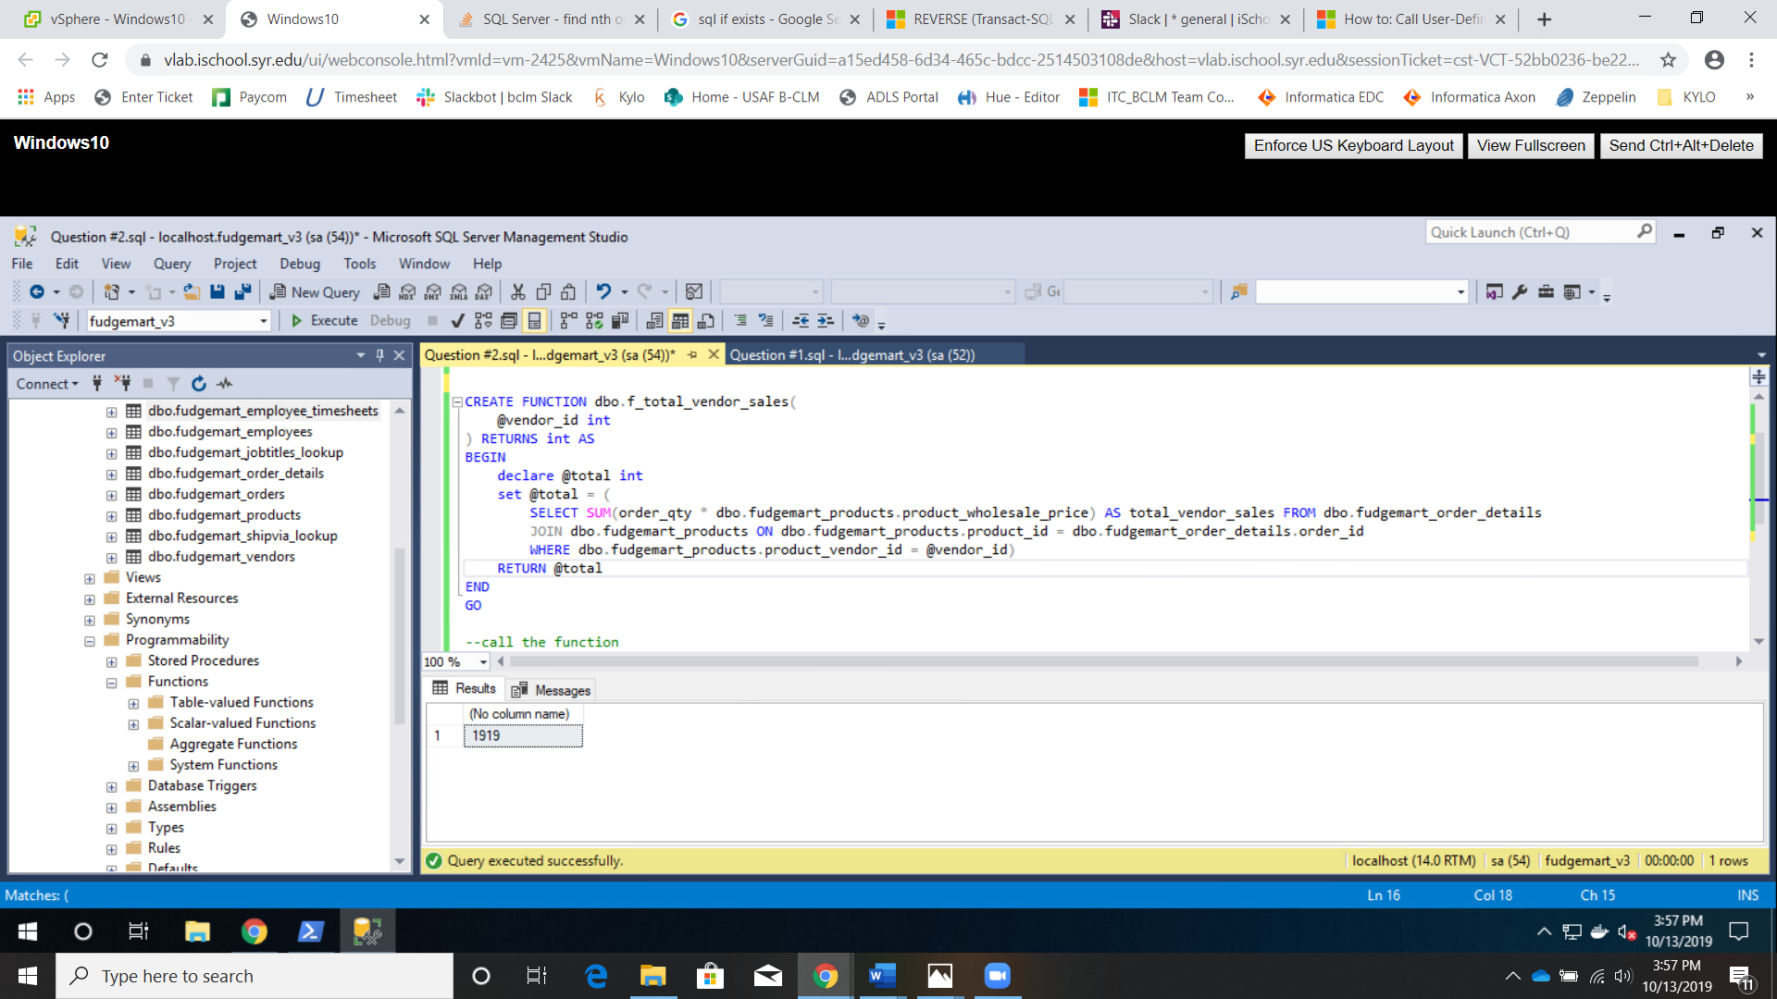

1. Write a stored procedure called **p_write_vendor** which when given a required vendor name, phone and optional website, will look up the vendor by name first. If the vendor exists, it will update the phone and website. If the vendor does not exist, it will add the info to the table. Write code to demonstrate the procedure works by executing the procedure twice so that it adds a new vendor and then updates that vendor’s information.

**SQL Query**

---which database to use--

USE fudgemart_v3

GO

----check if the procedure already exists, and drop it

DROP PROCEDURE IF EXISTS dbo.p_write_vendor

GO

--create the procedure

CREATE PROCEDURE dbo.p_write_vendor(

@vendor_name varchar(max),

@vendor_phone int

)AS

BEGIN

IF EXISTS(SELECT vendor_name, vendor_phone, vendor_website FROM dbo.fudgemart_vendors WHERE vendor_name = @vendor_name)

 UPDATE dbo.fudgemart_vendors

  SET vendor_website = @vendor_name + '.com'

  WHERE vendor_name = @vendor_name

ELSE

 INSERT INTO dbo.fudgemart_vendors(vendor_name, vendor_phone, vendor_website) VALUES (

 @vendor_name,@vendor_phone,@vendor_name+'.com')

END

GO

--call the procedure---

exec dbo.p_write_vendor 'Johnson', 123455

GO

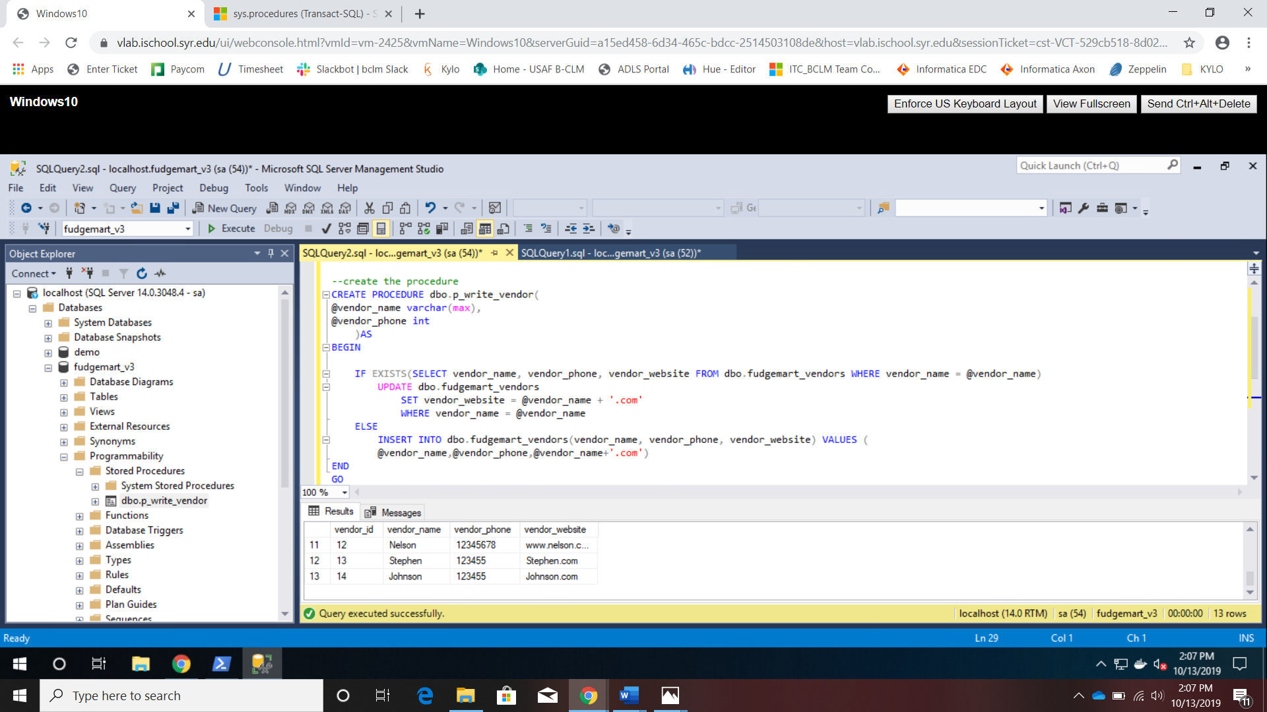

1. Create a view based on the logic you completed in question 1 or 2. Your SQL script should be programmed so that the entire script works every time, dropping the view if it exists, and then re-creating it.
2. Write a table valued function **f_employee_timesheets** which when provided an employee_id will output the employee id, name, department, payroll date, hourly rate on the timesheet, hours worked, and gross pay (hourly rate times hours worked).

**SQL QUERY**

USE fudgemart_v3

GO

DROP FUNCTION IF EXISTS dbo.f_employees_timesheets

GO

---create the function---

CREATE FUNCTION f_employees_timesheets(

@employee_id int

) RETURNS TABLE AS

RETURN(

SELECT timesheet_employee_id,dbo.fudgemart_employees.employee_lastname, dbo.fudgemart_employees.employee_department,

  timesheet_payrolldate,timesheet_hourlyrate, timesheet_hours, timesheet_hourlyrate * timesheet_hours AS gross_pay

 FROM dbo.fudgemart_employee_timesheets

 JOIN dbo.fudgemart_employees ON dbo.fudgemart_employees.employee_id = dbo.fudgemart_employee_timesheets.timesheet_employee_id

 JOIN dbo.fudgemart_departments_lookup ON dbo.fudgemart_departments_lookup.department_id = dbo.fudgemart_employees.employee_department

 WHERE timesheet_employee_id = @employee_id

)

GO

--call the function with employee_id equal to 1 ---

SELECT * FROM f_employees_timesheets(1)

GO

**OUTPUT**

